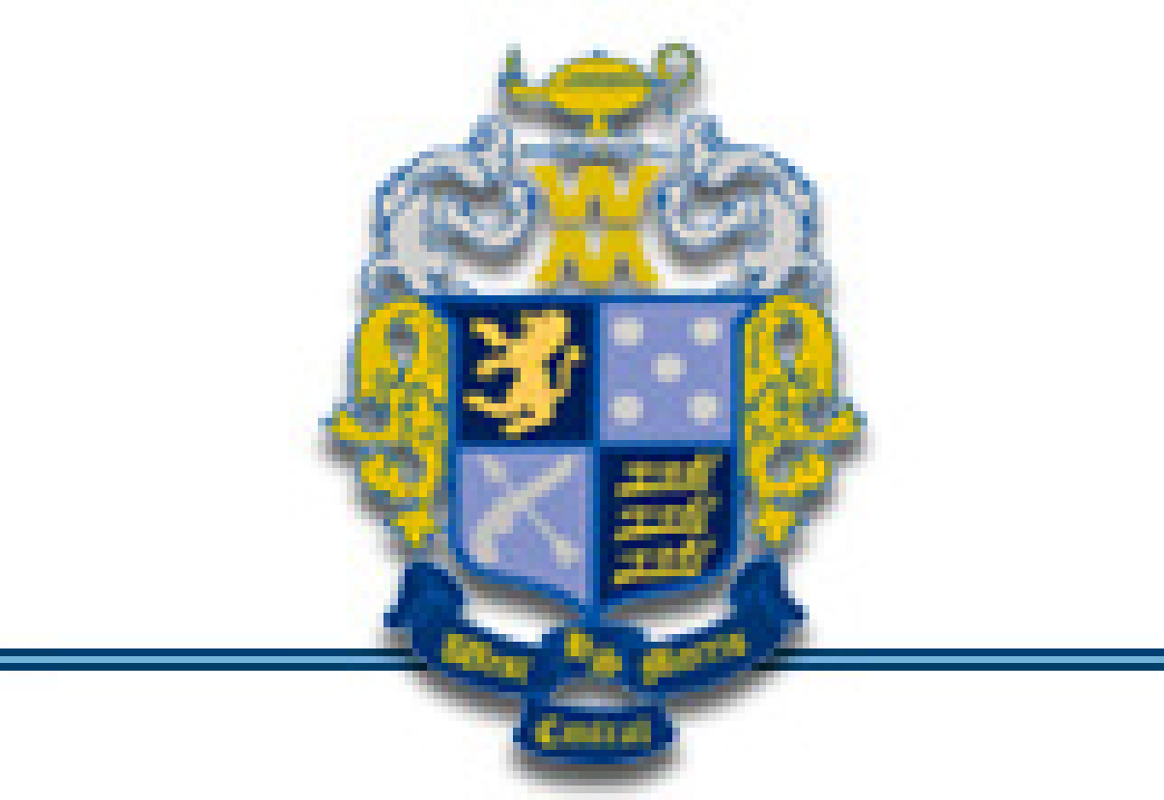

West Morris Central Project Graduation
PO Box 457
Long Valley, New Jersey 07853

R E G I S T R A T I O N

Project Graduation costs much more than is charged, and fundraising and community support will make up the difference in cost. Project Graduation is held on Graduation Night, Wednesday, June 21, 2017.

Cost of the event is $125 if payment is received by January 30, 2017
$150 if received after January 30, 2017

NO SENIOR WILL BE LEFT BEHIND DUE TO FINANCIAL RESTRICTIONS. A limited amount of scholarships will be available thanks to generous donations made by senior parents and some specific organizations. If there are particular financial difficulties please let one of the committee chairs know and we will contact you. This information will remain confidential.
PLEASE PRINT CLEARLY

STUDENT’S NAME: _______________________________________________________________

PARENT/GUARDIAN NAME: ________________________________________________________

SECOND PARENT/GUARDIAN NAME: _________________________________________________

PARENT PHONE: ________________________________ T-shirt Size: S M L XL 2XL 3XL

ADDRESS: ______________________________________________________________________

CITY: ______________________________________________________ ZIP: ________________

Email ___________________________________________________________________________
Please provide a parent email address. This email addressed will be used to communicate with you regarding Project Graduation (event detail including transportation times, event start/end times, and all the information you need to know about Project Graduation 2017). This email will only be used for Project Graduation 2017 communications.

PLEASE SEND COMPLETED FORM AND PAYMENT TO:
WMC Project Graduation
Attn: Registration
PO Box 457
Long Valley, NJ 07853

www.WMCHSProjectGraduation.com WMCProjectGraduation@gmail.com

