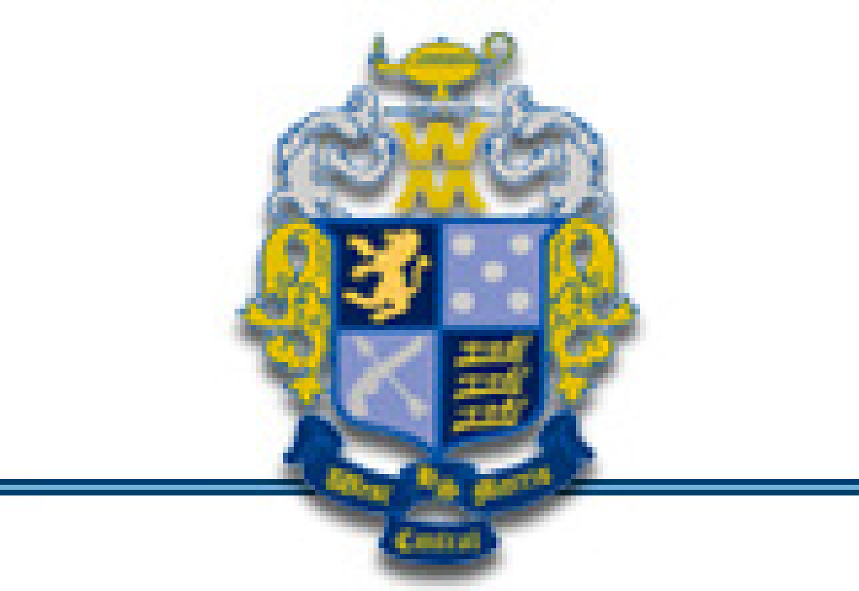
West Morris Central Project Graduation
PO Box 457
Long Valley, New Jersey 07853

November 2016
Dear West Morris Central Senior Families:
We hope that everyone has had a great senior year so far! We all face busy schedules, countless activities and commitments, and exciting milestones for our children. As parents of Seniors, we think you will agree that Freshman year feels like yesterday and we cannot believe that our children will be graduating on June 21, 2017 and taking the next steps in their bright futures.

West Morris Central Project Graduation is an event that takes place the night of graduation for all Seniors. A few parents of rising Seniors have been meeting to organize, plan, and begin to fundraise for the event. In our tenure as High School parents we’ve watched the three classes before us work very hard to run a successful event, and we’d like to do the same! We sponsor a number of fundraising events through the school year to benefit the community and help us raise money to offset the cost of an all-night event. This packet is to share information with you about our upcoming events, and ask for your help.

In the attached newsletter please read what the event is about and why we hold it. June 21, 2017 will be the last time the WMC Class of 2017 is all together, it will be safe and secure, and it will hold memories that will last a lifetime. If you want to learn more about Project Graduation, please visit our website, join our FaceBook page (WMC ProjectGraduation), or come to a Project Graduation Meeting (dates will be posted on our website). This is a large undertaking; we would welcome everyone’s participation.

Senior Project Graduation Registration: Register your senior by January 30, 2017 and save $25.00. Registration is $125.00 until January 30, 2017 and then goes up to $150.00. Every attendee will get a t-shirt!

Discount Cards: They are now available! Purchase a discount card and get savings at dozens of local vendors. Each card is $10 and it will pay for itself within a few uses. If every senior family purchases just one discount card we will be well on our way to paying for the buses for the night of the event!! Order a discount card by emailing us.

We also need volunteers to assist in the up and coming fundraisers:

Krispy Kreme: We will need folks to help sell Krispy Kreme from November 29, 2016 through December 12, 2016. Pick up will be December 21, 2016, outside the cafeteria, immediately after school. Forms will be distributed in your child’s English class. You can also find them on our website.

Dodgeball: Scheduled for March 3rd, 2017. We will need parent volunteers that night so please check in on our website if you are interested in helping.

Comedy Night & Silent Auction: Scheduled for April 20, 2017, we will be hosting talented comedians and a silent auction. We will need many to assist in getting the event together, provide donations for the silent auction, and help on the night of the event. It will take place at Black Oak Golf Club.

In addition to supporting our fundraisers, please consider partnering with us. We are a 501 (c) 3 organization, so you or your employer can make a tax deductible contribution. All donors are prominently thanked and acknowledged on our website and in our publications, including the booster book; we reach well over a thousand households in our community!

Please support our fundraisers, make a donation, or simply spread the word for us, all of our soon to be graduates will appreciate the event, and we’ll be creating lifelong memories for them!

Thank You!!! The 2017 West Morris Central Project Graduation Committee

